

AI FINAL PROJECT REPORT

SUBMITTED TO: SIR ADNAN KARAMAT
SUBMITTED FROM: MOMIN SAQIB NIAZI (BAI243073)

AI Project Report: Salary Prediction using Linear Regression
1. Project Overview
The objective of this project is to predict an employee's salary based on their years of professional experience. This is a Simple Linear Regression task where we use one independent variable to predict one continuous dependent variable.
2. Dataset Description
- Source: Kaggle (Salary Dataset).
- Features (X): YearsExperience (Numerical).
- Target (y): Salary (Numerical).
- Size: 30 entries (split into 80% Training and 20% Testing).
3. Methodology
- Algorithm: Linear Regression.
- Tools: Python, Pandas, Scikit-Learn, Matplotlib.
- Implementation: The data was split using train_test_split. The model was trained using the LinearRegression() class from Scikit-Learn.
4. Results & Performance
Based on the implementation in Google Colab, the model achieved the following performance:
- $R^2$ Score (Accuracy): 0.9024
- Interpretation: An $R^2$ score of ~0.90 means that approximately 90% of the variance in salary can be explained by the years of experience. This indicates a very high level of accuracy for the model.
5. Conclusion
The visual representation shows a strong positive correlation. The blue regression line closely follows the actual red data points, proving that as experience increases, salary increases in a predictable linear fashion.

CSV FILE:
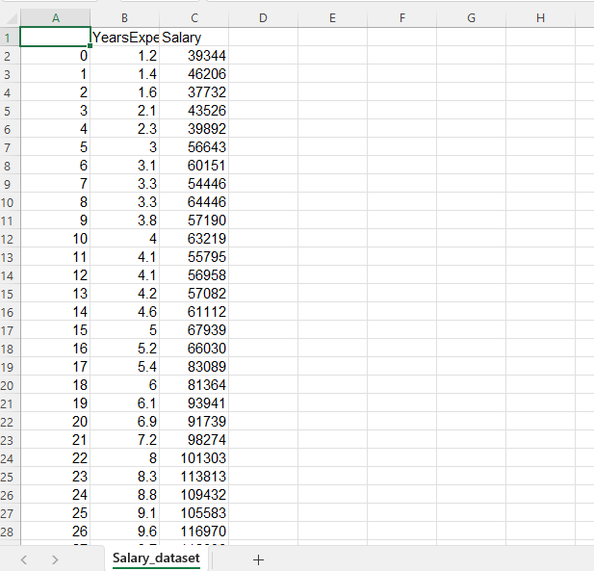

CODE:
import pandas as pd
import numpy as np
import matplotlib.pyplot as plt
from sklearn.model_selection import train_test_split
from sklearn.linear_model import LinearRegression
from sklearn.metrics import mean_absolute_error, mean_squared_error, r2_score

# Load and clean data
df = pd.read_csv('Salary_dataset.csv')
X = df[['YearsExperience']]
y = df['Salary']

# Split, Train, and Predict
X_train, X_test, y_train, y_test = train_test_split(X, y, test_size=0.2, random_state=42)
model = LinearRegression()
model.fit(X_train, y_train)
y_pred = model.predict(X_test)

# Show results
print(f"R2 Score: {r2_score(y_test, y_pred)}")
plt.scatter(X_test, y_test, color='red', label='Actual')
plt.plot(X_test, y_pred, color='blue', label='Predicted')
plt.legend()
plt.show()
